ODBC Adapter Development Tools and Considerations

ODBC Adapter Design Notes
The ODBC adapter described in this document is a work in progress. It was designed and develop to help BizTalk developers quickly address basic database integration using ODBC. The adapter described here was developed using the ODBC provider for ADO.NET. It was a conscience design decision NOT to use the OLEDB provider as test against rare databases such as PICK and others did not interoperate with the OLEDB driver for ODBC. That said there is no free lunch and using ODBC exclusively presents its own challenges.

So you’re asking yourself just what is this adapter capable of? Since it’s based on ADO.NET and the ODBC provider just about any query that works in a .NET application using the ODBC provider will work in the ODBC adapter. In fact the ODBC adapter was designed against the SQL Servers adapter paradigm and its designed tried to address some of the SQL adapter’s limitation.

The ODBC adapter supports
Stored Procedures with out parameters (If the ODBC driver supports them)
Compound queries – More then one query performed in a single pass
Parameterization of raw SQL Statements (Enter your own SQL statements with parameters)
Batched quires – The request XML document can be nested with multiple parameter sets

No free lunch
Stored Procedures
The adapter has been tested against several databases. It’s been determined that the user enter SQL is the most supported by the ODBC drivers. Store procedures are some times a problem with the ODBC provider for ADO.NET. The problem most often lies in the “DeriveParameters” method of the provider when trying to resolve input and output parameters. The problems are directly related to the quality of the ODBC driver not the ODBC adapter or ADO.NET. SQL Server works great but other database are hit and miss! Try it out and see what happens!

Transactions
The ODBC adapter implements ADO.NET transaction but due to time constraints enterprise services have NOT yet been implemented. This means that if a failure occurs in the ODBC adapter while attempting to process the query the transaction will be rolled back and retired after the specified interval. However, the adapter will NOT PARTICPATE in a two phase commit in this version (Hey I have a day job ;-) If you interested in implementing this feature we can certainly provide guidance.

Memory Management.
Everything with in reason was done to ensure that the adapter could process large data payloads. However, ADO.NET has very limited support for streaming. As a result during data base write operations, the ADO.NET command object loads all data to be processed into memory. This could result in performance issues. On the receive side, some streaming is supported and has been implemented.

Type Conversion
The adapter does a best guess on data type conversions. This guess is based on the ODBC ADO.NET documentation. It is also contingent upon the data types supported by the ODBC driver. Most of the common data types are mapped usefully. Things become more interesting as you get into the area of binary data. All of SQL’s binary types are supported and the adapter can get at many other database binary types but things like DB2’s CBLOB give ODBC a problem (This could again have something to do with the driver we were using during testing).

Orchestration Generic Message processing using XMLDocument Message type
If you try to design a generic orchestration that will simply process SQL queries generated using the ODBC adapter you will probably attempt to define the messages in your orchestration and XMLDocuments. This approach works with some adapters but the ODBC adapter needs to know the assembly strong name for the schema being processes at run time. It uses this information to pull the schema from the assembly during message processing. The schema contains the meta data needed by the adapter to process the query correctly (The schema contains the SQL, document element names etc).

If the orchestration defines its internal messages as XMLDocument type, the adapter receives the message as normal but the assembly name now provided by BizTalk server is for the BizTalk XML base types NOT the source assembly for the schema.

Deployment

Adapter Configuration
Once the adapter has been installed, we need to register it with the BizTalk administration tools and configure its settings.

Launch the BizTalk Administration Console
Expand the Microsoft BizTalk Server 2004 (local) node from the tree view
Right click on the “Adapters” folder and select “New” then “Adapter”
The Add Adapter dialog box will appear

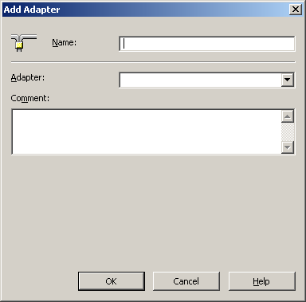

In the Name field enter Community ODBC
From the Adapter drop down select “ODBC”
Click on the [OK] button.
Expand the Adapters folder, you should now see a “Community ODBC” adapter node
Expand the “Community ODBC” node
Select the “Receive Handlers” folder
Select the BizTalk host under which the ODBC adapter should run then right click and select properties
The BizTalk Application Properties dialog should appear. Select the “Properties” tab

ODBC Receive Handler Configuration
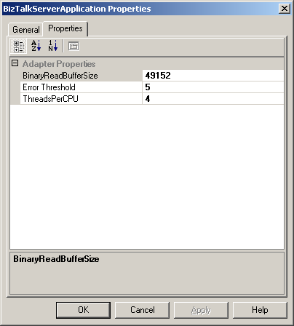
The memory block size the adapter should use when reading binary data from the source database. This number is in bytes
The total number of significant errors that the adapter should tolerate before suspending processing (NOT IMPLEMENTED in this code drop)
Total number of threads that the receive service should initialize per CPU on a given server.

On the properties tab you can set the appropriate values for the ODBC receive adapter
Once you have completed the ODBC receive host click the [OK] button.
Now click on the “Send Handler” folder from the tree view
Right click the BizTalk Host under which the ODBC adapters send services will be hosted and select properties
Select the “Properties” tab of the BizTalk Server Application Properties dialog

ODBC Transmission Handler Configuration
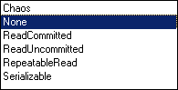
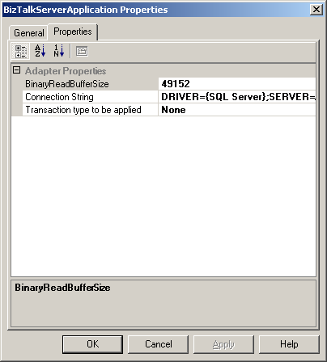
The memory block size the adapter should use when reading binary data from the source database. This number is in bytes

This number has limited affect on the transmit functions as the ADO.NET command object has no concept of streaming. As a result sending a payload thru the adapter will require heave use of physical memory
Default DSN for the send locations
Default ADO.NET transaction type for the send location.

Click the [OK] button to commit the changes.

Building your first project with the ODBC Adapter

Launch and create a new BizTalk project in VS.NET
Once the project has been initialized right click on the project node in the VS.NET and select Add -> Add Generated items menu
From the “Add Generate Items” dialog select “Add Adapter”

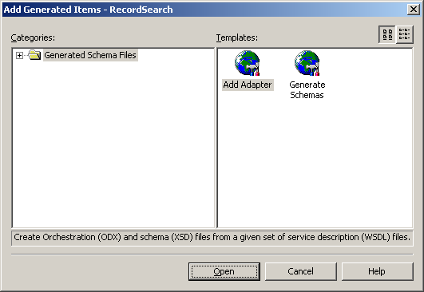

From the “Add Adapter Wizard” dialog select “ODBC”

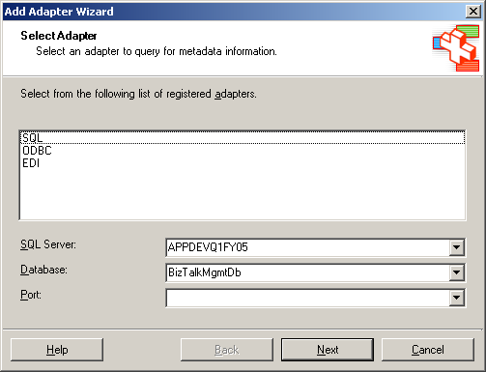

Click “Next”: This will launch the ODBC Transport Schema Generation Wizard

Database Information
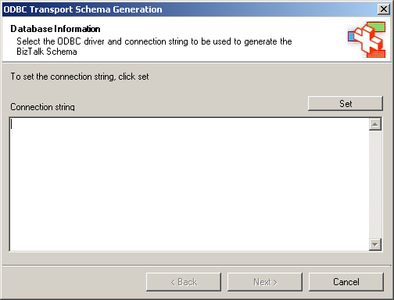

You can either manually enter a connection string or DSN into the connection string textbox or click the set button to launch the DSN dialog. NOTE: In many cases ODBC drivers require a ton of configuration data to work correctly. DSN’s allow you to abstract this information in most case. However, passwords are not normally stored as part of DSN data. As a result, we may need to manually enter a password to connect to the target database to generate the BizTalk schemas. If you are manually entering a DSN name you can simply add “;pwd=mypassword” to the end of the DSN=MyDatabase string.

The ODBC DSN dialog provides a facility for capturing this information automatically.

OK, so now you saying “NO WAY, I’m not storing my passwords in the clear!” Well fear not! We only need the password to connect and generate your schemas. We do not store the passwords anywhere as part of the schema generation process.

Click [Next] to continue

Schema Information
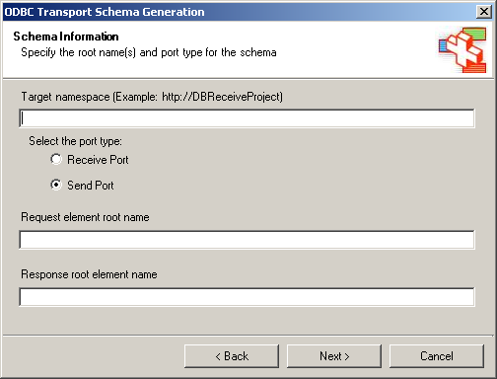

The Schema Information dialog allows you to uniquely identify your generated schemas. The “Request” and “Response” element textboxes appear based on whether the schema is being generated for a receive or send port. The does basic validation but DOES NOT confirm that you schemas are unique to all BizTalk Schema deployed (This would be a fine feature for you to implement. Remember you have the source code! ;-).

DESIGN NOTE: Not all send port based schemas will actually result in two schemas being generated: Send and Receive. In cases where you select to perform write only operations, only a send schema will be generated. The adapter wizard will evaluate your selections and generate only those schemas require to perform the query. So don’t expect in all cases that after you enter “Response root name” that you will always have a response document.

Click [Next] to continue

Statement Type Information
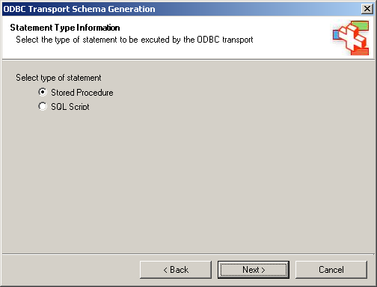

The Schema Type Information dialog allow you to specifically which type of SQL statement the ODBC adapter wizard will be generating a schema to represent. It is at this step that the ODBC schema wizard takes one of two paths: Generate a schema based on a stored procedure name or on user entered SQL statements.

Click [Next] to continue

Statement Information (Stored Procedure)
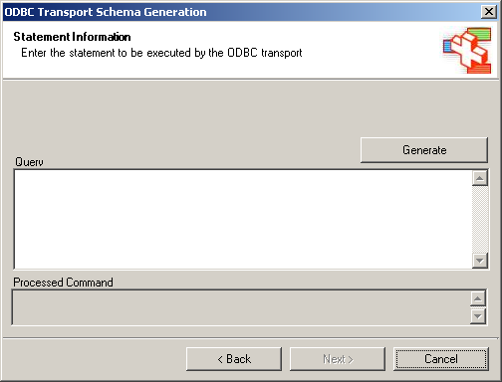

The “Statement Information” dialog box allows you specify the SQL statement to be performed. In this case it’s a stored procedure. To specify the stored procedure simply enter the store procedures name and click [Generate] (ONLY ENTER THE NAME do not specify parameters or command or other SQL artifacts). The ODBC adapter wizard will then attempt to resolve the parameters using ADO.NET’s ODBC provider. If you are having problems generating the store procedure command. Please review the ADO.NET documentation on the type of stored procedure being invoked.

Certain naming conventions and dot based notation are not support by the ODBC provider. It is also at this stage that the ODBC adapter wizard attempts to connect to the source database using the DSN or connection string you provided in earlier steps.

If the stored procedure processed successfully you should see an entry in the Processed Command textbox. The [Next] button will also be enabled upon successful processing of the stored procedure.

Statement Information (SQL Script) 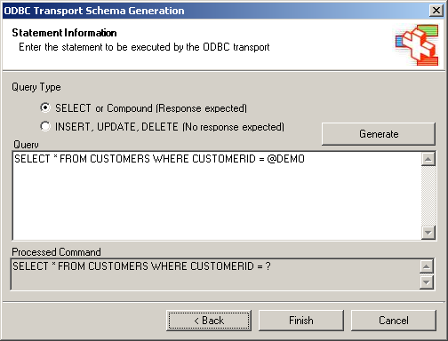

When the SQL Script option is select you can enter in raw SQL into the “Query” textbox. The “SELECT” and “INSERT” radio buttons tell the adapter wizard whether it should produce an output schema. OK so that has to be confusing…

SELECT or Compound (Response expected) Option
The “SELECT or Compound (Response expected)” option tells the schema wizard that the query will contain one or more SQL statements that will product an output. For instance a SELECT statement should produce some kind of output. But what if you want to do something more interesting like say an INSERT then do a SELECT to get the index generated for the INSERT. This option allows you to compound these kinds of mixed statements.

Please understand that you are not restricted to just basic queries. If you can get a query to work with ADO.NET and the ODBC Provider then it should work in the adapter. This approach can also be used in those situation where the standard stored procedures functions in the wizard fail. In this case, you could hand code the call to the stored procedure. Of course you could only pass “in” parameters.

You could also perform multiple SELECTs it’s really dependent on the ODBC driver and the database being queried. These also impact the SQL that is supported. During testing it was discovered that SQL Server 2000 and very easily deal with:

SELECT * FROM CUSTOMER
SELECT * FROM EMPLOYEES

But DB2 preferred:
SELECT * FROM CUSTOMERS;
SELECT * FROM EMPLOYEES;

And the MS Oracle Driver didn’t like either but wanted UNION statements
INSERT, UPDATE, DELETE (No response expected) Option
This option is for those cases where no response is required say a simple insert or update. When this option is select NO RESPONSE schema is generated even though you entered a response schema root node name in the Schema Information dialog.

Parameters
Of course this wouldn’t be a very useful adapter if all it did was process the data you entered into the query window. To specify parameters all that is required is to place an “@” (@MyValue) in front of the term representing your parameter. You can name these parameters anything you wish. When the adapter wizard generates the schema it will generate an input schema with your parameters added as attributes. The @ will be removed.

Once again you will need to click on generate to have the adapter wizard process the quer for schema generation. If the schema is successfully derived from the query entered, the ADO.NET escape sequence will appear in the “Processed Command” textbox and the “Next” button will be enabled.

IMPORTANT SAFETY TIP: When entering raw SQL the adapter wizard cannot derive the data types for the parameters. It will default the data type to string. Once the schema has been added to your project in VS.NET you can edit the schema and change the data type of the parameter attributes to the appropriate type.

For instance, say you wanted to write an image to the database. One of your query parameters many be named photo. When the adapter wizard generated the schema the data type would be string. But we know that the database is expecting binary and you would like to encode the data as Base64 in the XML document. You would then open the generated schema and change the data type to Base64.

When the message is received by the ODBC adapter if will evaluate the XML data type and map it to the appropriate ODBC data type. In this case, the adapter with take the photo element and convert it to a byte array when it is written to the database.

This is one of the coolest pieces of the adapter, if I do say so myself ;-)

Finishing
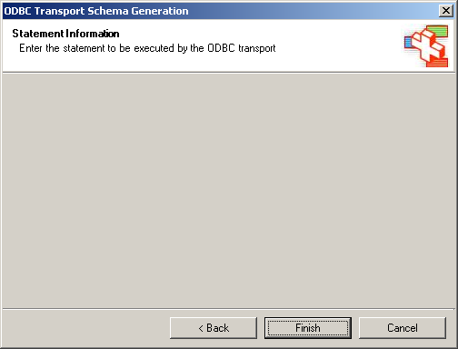

To finish the schema generation process click on the [Finish] button. At this point the schemas generated will be added to your project. A bogus orchestration will also be added to your project, this is not required and can be deleted (No this is not my bug, I’ve got plenty of others but not this one ;-)

Have fun!

Test Harness

Schema Wizard Test
Schema Wizard Test tab allows you to test the schema generation code of the ODBC adapter as well as the ODBC wizard. The Test Harness allows you to do this without the need to fully deploy the adapter or launch Visual Studio.NET. If you’ve had the pleasure of developing dynamic BizTalk 2004 adapters I think you’ll find this a great time saver! (HOWEVER, it is important to note that this feature DOES NOT TEST the WDSL code used to load the schemas into VS.NET at design time).

To test schema generation just click on the [Test ODBC Wizard] button and walk through the schema generation wizard.
Displays the ADO.NET ODBC provider escape sequence generated by the adapter. This is particularly important when calling stored procedures
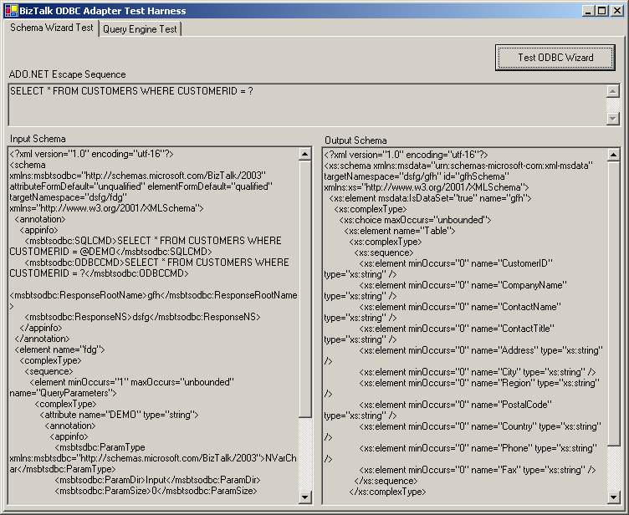
Click on this button to launch the schema generation wizard
This field will display the input XML schema generated by the adapter. The input schema text box will only be populated if “Send Port” was selected in the ODBC wizard.

If the adapter had been run from VS.NET then the schemas would have been added to the project.

This field will display the output XML schema generated by the adapter. The output schema text box will only be populated if “Send Port – Compound statement or Receive Port” were selected in the ODBC wizard.

If the adapter had been run from VS.NET then the schemas would have been added to the project.

Query Engine Test
The Query Engine Test tab of the Test Harness application allows you to test the ADO.NET based query engine underlying the ODBC adapter without the need to build VS.NET BizTalk projects or configure BizTalk send and receive ports. This feature also allows you to stress test just the query engine for the ODBC adapter (Also see performance monitoring for gathering stress test metrics).

This tool would be good to use to validate that your queries are processed correctly before going through the standard BizTalk project deployment tasks.
An input XML schema generated by the ODBC adapter. These would the schemas generated in VS.NET at design time

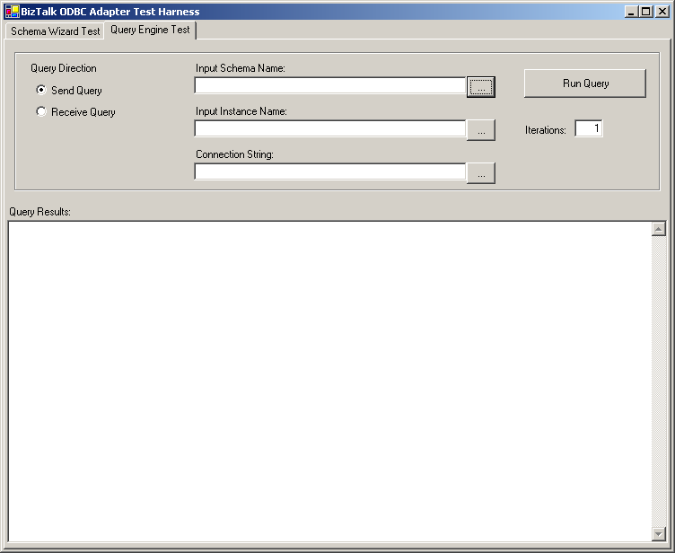
Specify the ODBC DSN to be used for the test. The […] will launch the DSN dialog.
Select a valid XML representation of the data described in the input schema. This would be a sample query.

This test supports any query supported by the adapter/ADO.NET and the ODBC driver
Indicates the query direction executed. This is important as send and receive queries are processed using slightly different paths
How many times do you want the test performed. User primarily to test adapter code and performance

The output from your query test.

Port Configuration

Send Port
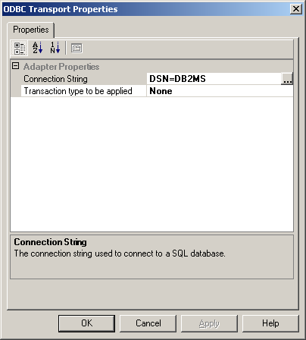
DSN for the send locations
ADO.NET transaction type for the send location.

Receive End Point Configuration
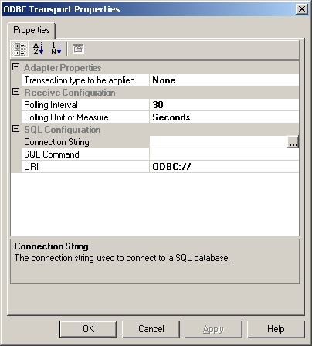
Default DSN for the send locations
ADO.NET transaction type for the send location.
Frequency at which the query will be performed

The SQL Command field will launch the schema selection dialog.

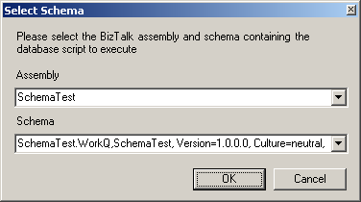

You use this dialog to select a BizTalk assembly that contains a schema representing an ODBC query. A receive end point CANNOT use a query that contains parameters. If you select such as schema, the end point configuration validation will throw an error informing you that you have violated this condition

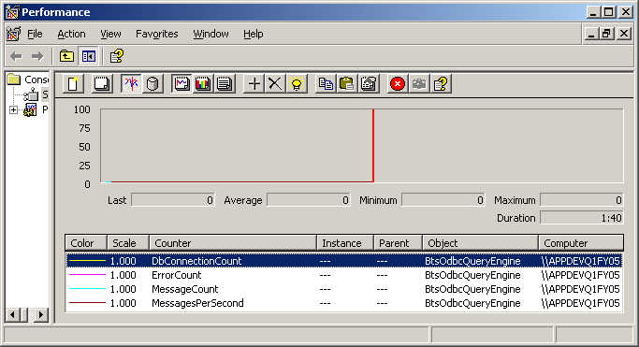

For Developers

Using other providers
If the ODBC provider isn’t meeting your needs you can certainly edit the adapters code. The majority of the ODBC specific code is contained in ODBCCommandProcessor project and the ODBCSchemaHelper.cs contained in the ODBCSchemaWizard project. These projects could be converted to other providers by simply changing the provider types and namespace references. This would address about 80% of the work.

The major rework would need to take place in the type matching function used to convert XML based data types to .NET to ODBC. You will also need to replace the ODBC Connection Help project with the appropriate provider connection management dialogs.

Common Errors

“No root element” – This is an interesting error, in most cases it just requires that the BizTalk Service under which the adapter is running is recycled. The most common reason for this is new schema deployment. The ODBC adapter uses the BizTalk explorer object model to extract meta data from the schema for a message. The BizTalk explorer object model will cache data which in some cases causes the adapter not to find “new” schemas in some cases. The reason we get the root element not found error is the adapter cannot interpret the xml message.

Don’t worry we don’t loose the messages; once the service is recycled they will be processed!

